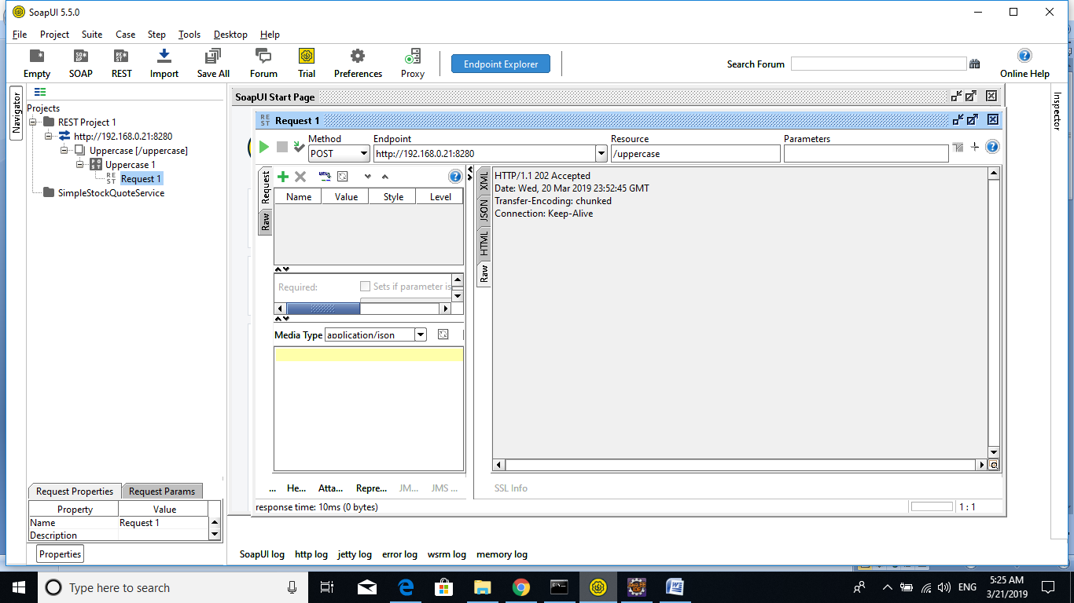

[2019-03-21 05:22:26,542] [] INFO - SequenceDeployer Sequence named 'callClassMediatorSeq' has been undeployed

[2019-03-21 05:22:26,546] [] INFO - ClassMediatorDeployer Undeploying Class mediator : JavaMediatorHMRCsample-1.0.0.jar

[2019-03-21 05:22:26,550] [] WARN - SynapseAppDeployer Couldn't delete App artifact file : C:/PROGRA~1/WSO2/ENTERP~1/64BE80~1.0/bin/../wso2/tmp/carbonapps/-1234/1553125826038HMRCMediatorDistrib_1.0.0.car/JavaMediatorHMRCsample_1.0.0\JavaMediatorHMRCsample-1.0.0.jar

[2019-03-21 05:22:26,567] [] INFO - ApplicationManager Successfully Undeployed Carbon Application : HMRCMediatorDistrib_1.0.0 {super-tenant}

[2019-03-21 05:22:26,567] [] INFO - ApplicationManager Deploying Carbon Application : HMRCMediatorDistrib_1.0.0.car...

[2019-03-21 05:22:26,677] [] INFO - ClassMediatorDeployer Deploying Class mediators from file : C:\PROGRA~1\WSO2\ENTERP~1\64BE80~1.0\wso2\tmp\carbonapps\-1234\1553125946568HMRCMediatorDistrib_1.0.0.car\JavaMediatorHMRCsample_1.0.0\JavaMediatorHMRCsample-1.0.0.jar

[2019-03-21 05:22:27,100] [] INFO - DependencyTracker Sequence : callClassMediatorSeq was added to the Synapse configuration successfully - [ Deployed From Artifact Container: HMRCMediatorDistrib ]

[2019-03-21 05:22:27,100] [] INFO - SequenceDeployer Sequence named 'callClassMediatorSeq' has been deployed from file : C:\Program Files\WSO2\Enterprise Integrator\6.4.0\wso2\tmp\carbonapps\-1234\1553125946568HMRCMediatorDistrib_1.0.0.car\callClassMediatorSeq_1.0.0\callClassMediatorSeq-1.0.0.xml

[2019-03-21 05:22:27,109] [] INFO - API Initializing API: callClassMediator

[2019-03-21 05:22:27,110] [] INFO - DependencyTracker API : callClassMediator was added to the Synapse configuration successfully - [ Deployed From Artifact Container: HMRCMediatorDistrib ]

[2019-03-21 05:22:27,112] [] INFO - APIDeployer API named 'callClassMediator' has been deployed from file : C:\Program Files\WSO2\Enterprise Integrator\6.4.0\wso2\tmp\carbonapps\-1234\1553125946568HMRCMediatorDistrib_1.0.0.car\callClassMediator_1.0.0\callClassMediator-1.0.0.xml

[2019-03-21 05:22:27,118] [] INFO - ApplicationManager Successfully Deployed Carbon Application : HMRCMediatorDistrib_1.0.0 {super-tenant}

[2019-03-21 05:22:44,339] [] INFO - LogMediator To: /uppercase, MessageID: urn:uuid:e7a91658-043e-4646-b79e-dfc54050f26e, Direction: request, ======================= = Suresh kammais lives at HYDERABAD

[2019-03-21 05:22:45,856] [] INFO - LogMediator To: /uppercase, MessageID: urn:uuid:e2695541-2226-403b-a127-9c9c84bda6b8, Direction: request, ======================= = Suresh kammais lives at HYDERABAD

